***PROJECT REPORT***

***ON***

***“WEB DEVELOPMENT ON WOMENS EMPOWERMENT”***

***PROJECT TITLE***

***“STREE SHIKSHA”***

***DEVELOPED BY***

***TEAM NAME : “INFINITE TRAVELLERS”***

***TEAM MEMBERS :***

***PUNDAMALLI DINESH***

***KURUKOOTI CHANDRA KARTHIK***

***From python-G27 batch***

***Sure trust***

***INTRODUCTION:***

***Women’s Education is essential for the development and progress of any society. Educated women have the potiential to become strong leaders, role models, and agents of change in their communities. They are more likely to participate in the workforce, earn higher wages, and provide for themselves, their families and society.***

***In Article 14 (D) sets out right to education of rural women, which includes the right to obtain all types of training and education, formal and non formal, including that relating to functional literacy.***

***ABSTRACT:***

***In rural areas several house hold women’s who are intrested to learn but unable to go to educational institutions exept for exams. By considering all the people especailly for the women’s. We are developed a website which provides easy to access a right and better understandable educational videos from various sources and we are analysed provided that links in our website it would give easy to access the right content without any delay of time and even reach the content without any ambiguity.***

***So we are worked to develop a website called “STREE SHIKSHA” for women’s education as to access the high quality and understanding videos related to some educational standards. Which are suggested from various freely available sources and also included some of the trusted sites which may provide free courses with certificates are included in our site. Which are helps to learn easily without any delay to search better quality of educational videos from any sources without any ambiguity. By this the women would like to learn independantly without any suggestions from others even it is also used for all the students and especially the house hold women’s who are intrested to learn but unable to attend the educational institutions.***

***“Our main motto is to convey the knowledge through STREE SHIKSHA web site to all especially for womens.”***

***REQUIREMENTS FOR THE PROJECT:***

1. ***HTML***
2. ***CSS***
3. ***JAVA SCRIPT***

***PROCEDURE :***

1. ***By using the tools html, css, java script for assigning structure, style and interactive content respectively to our website ‘STREE SHIKSHA’.***
2. ***We are providing six tabs on the starting interface of the website. As shown in below.***

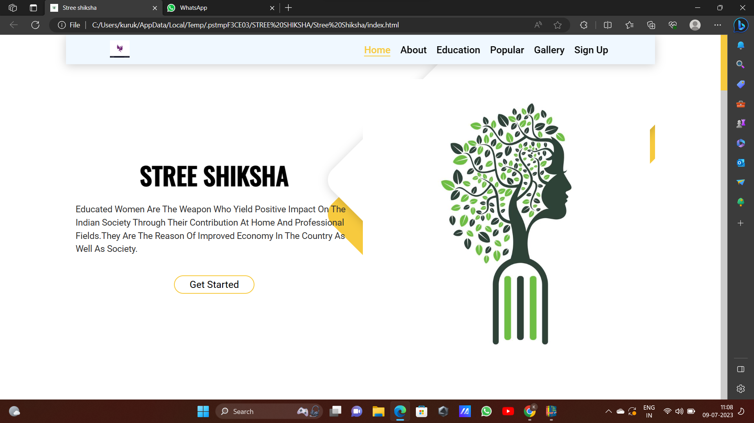

1. ***In home tab we provided the importance of women’s education as shown in above.***
2. ***In next tab ‘About’ we provided our team project abstract as shown in below.***

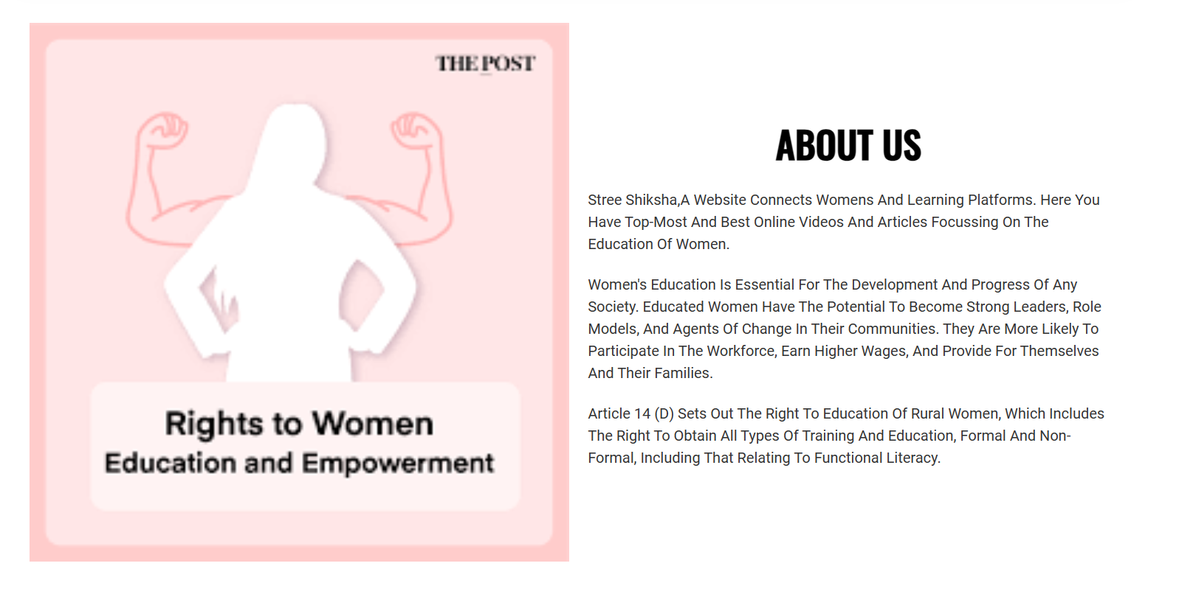

***v. Then we arranged some educational domains ie. Ssc , intermediate, technical and general knowledge. Which are redirected to their related sites.***

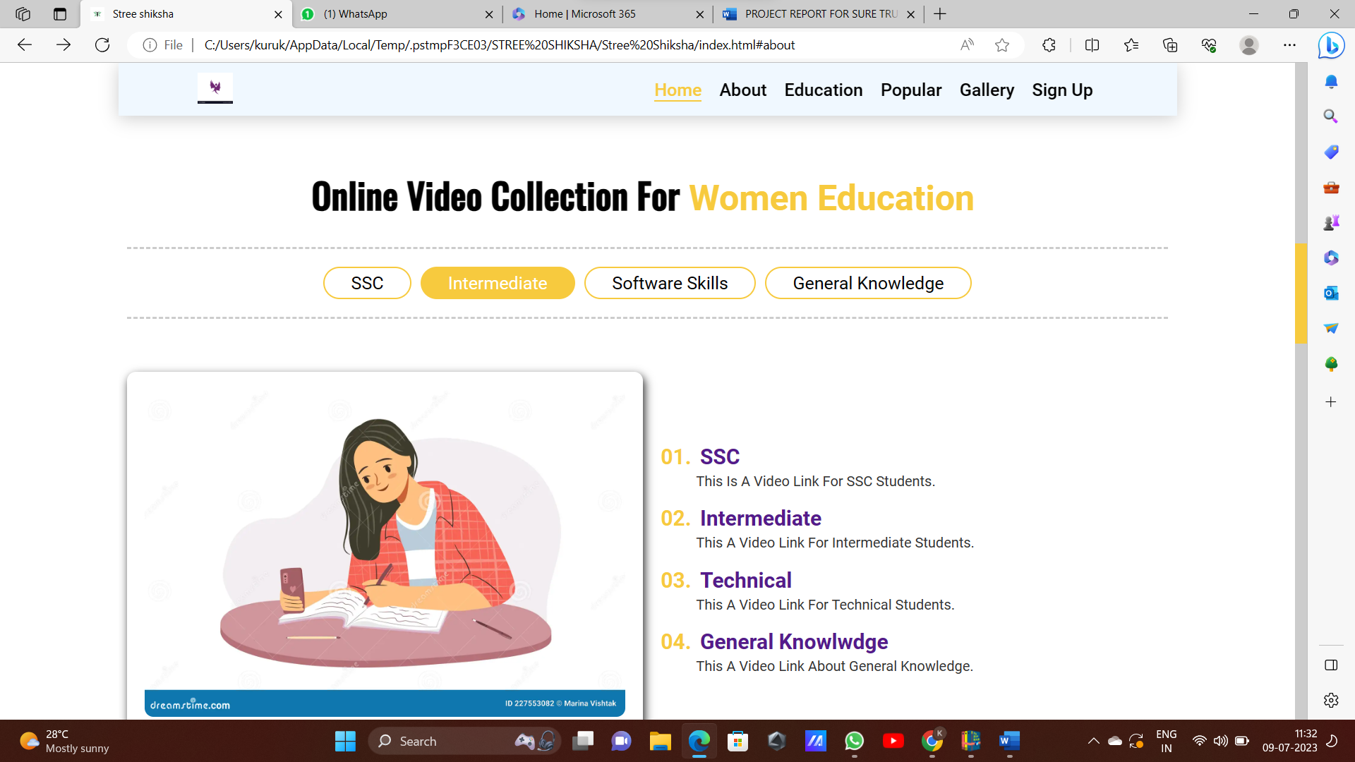

***vi. then we provided popular E-learning platforms are shown in below.***

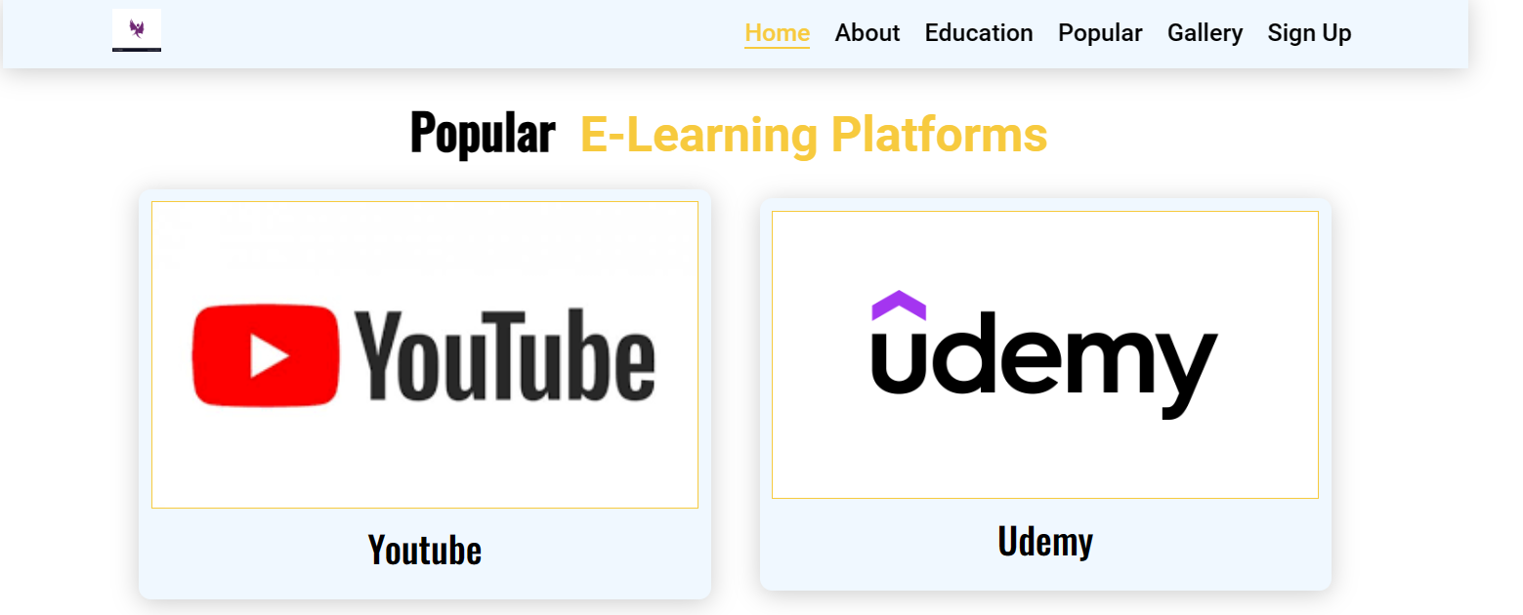



***vii. Then we arranged a gallery which consist of some most influenced woman in education. For inspiration to the women who are reached to our site.***

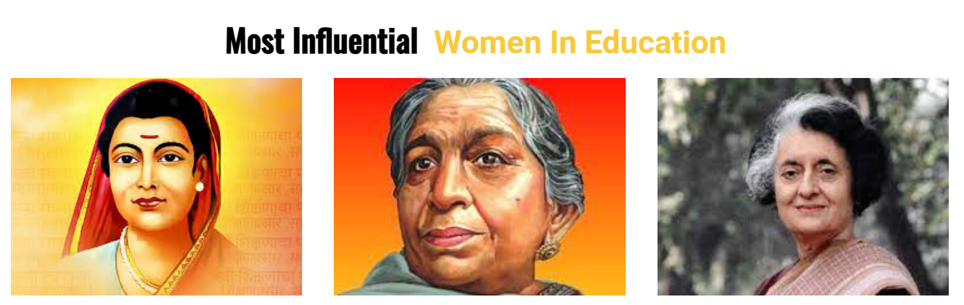

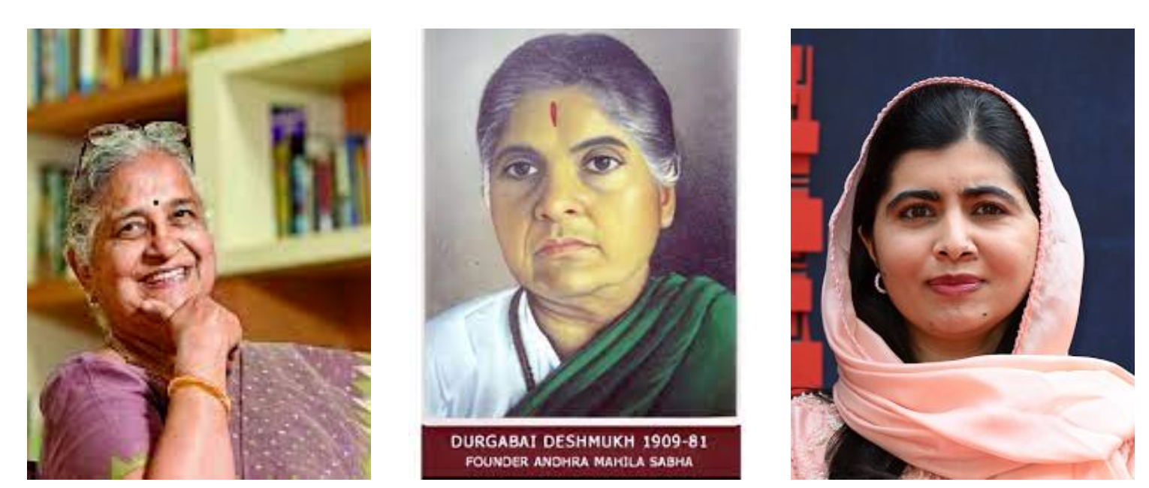

***viii. Finally we are design a ‘signup’ interface only and we are not design it in complete level due to insufficient time.***

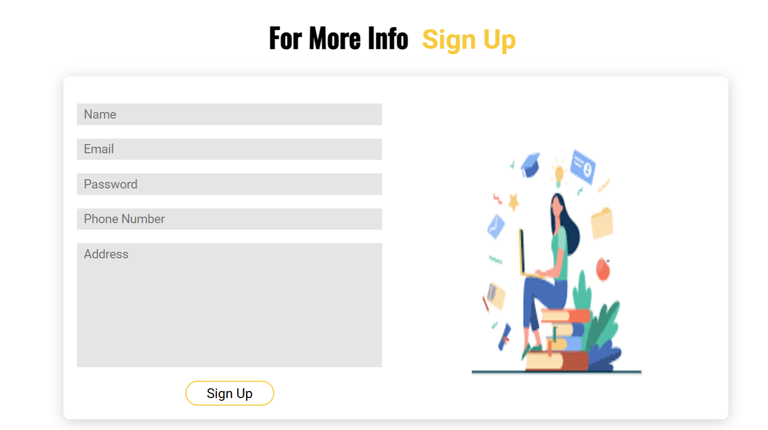

***Conclusion:***

***So, through our website “STREE SHIKSHA”, In rural areas several house hold women’s who are intrested to learn but unable to go to educational institutions. By considering all the people especailly for the women’s. We are developed a website which provides easy to access a right and better understandable educational videos from various sources and we are analysed provided that links in our website it would give easy to access the right content without any delay of time and even reach the content without any ambiguity. We think it may benefit to women’s for education.***